I am so  looking forward  to spending this  wonderful time with  my beautiful and fun  daughters!  With love,  Mom |  | Event  Guide & Planner  Do on your own:  Massage  We four do together:  (We can do all these on one big day out, or on two separate days; how ever we all agree works best for us!)  Pedicures  Go out to Lunch  Creative time

The Event Guide/Planner

Print out two or three this page containing the above guide/planner, and cut at about 5 inches wide, and about 3¾ inches high. Or don’t worry about measuring the page, and just cut about ¼ inch from the widest part of the right (menu) side, and ½ inch longer than the bottom of it, and then fold in half. You will need to mess around with this a bit with this as I am at Disneyland while finishing this blog post, and realized too late that I do not have access to a printer. And since Mother’s Day is the day after we get back, I didn’t want to wait another year before being able to post this! If you figure out the exact measurements, please let me know (via email ~ beshelton@aol.com ~ or via Facebook ~ “Barb Edtl Shelton”) as I AM able to edit and re-upload documents! I apologize for any inconvenience or downright irritation!!!

Cut this out and adhere to the front side of the above guide: (Please let me know if this doesn’t fit
correctly on the front. My intent is that it be a little smaller than the cover.)
Guide

for
Pampering
and
Creative
Events

Tags For The Money Packs
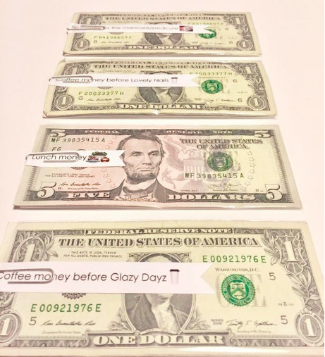

Slice these tags at whatever width and length you want. Between ½ inch and ¾ inch is good.
Or you can cut them in rectangles and paper clip to the top. (1.5” high by about 4” wide)
I like to leave enough paper (or cardstock) on the right side to make a little banner cut, as pictured. (Snip in to the center from the outside edge on top and bottom.)
I give several options for different meals or pampering, plus a second generic option for “creative time” since not everyone has a “Glazy Dayz” in town.

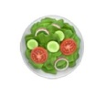
money to go out to lunch money to go out to dinner

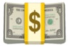
tip money for pedicure tip money for manicure

coffee money for pedicure coffee money for manicure

coffee money for Glazy Dayz coffee money for creative time

