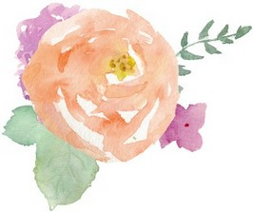
Hello, ________!

I want to run an idea by you of the Bridal Blessing Blitz [or “Bless-the-Bride” Blitz] I’m thinking of doing a for your sweet [daughter / friend / sister] [her name]. Allow me to explain how it works, and then tell me what you think. And I will be doing all the coordinating of this! So this isn’t something I’m putting on you to do, other than giving me a little input and names, which I’ll get more specific on herein.

Basically what it is is that each day leading up to the wedding, one gal (or even guy) – a friend or family member of hers – takes one day and blesses her in some way. It could be a heartfelt letter they write and drop off for her at work or at home, a plate of (her favorite) cookies, a favorite or special book, taking her out for coffee, lunch or breakfast, or if she's too busy, dropping of her favorite latté or lunch at work or home, or a sentimental gift.

So she gets a blessing of some sort each of the final days leading up to her wedding. If you think someone would want to do something on the actual Wedding Day, we’ll include that day too.
So is this something that you think she would enjoy? I know the final days leading up to a wedding can be intense, so I don't want to burden her with even more things to do. I'm starting with you so that you can tell me if "any of the above" would be best to ask the Blessers to not to do.

If some other ideas of what would bless her, come to mind, please let me know!

And then, finally, I can think of several people to include in this [name them], but can you give me their names and contact info ~ preferably Facebook name, email, or cell number to text as I'll be writing to everyone at the same time, and also linking them to a sign-up page.

And don't worry about numbers. If there are more than enough people to have one person a day do something for a couple of weeks (or even a month) before the wedding date, she could even get blessed twice a day!

NO worries at all if this just feels like too much to even think about. I seriously will not be offended if you’d just rather leave it!! OK?! You just let me know what you think!

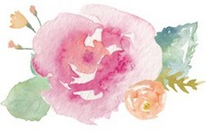
Love and hugs,
[Name]

