Recipe Notebook

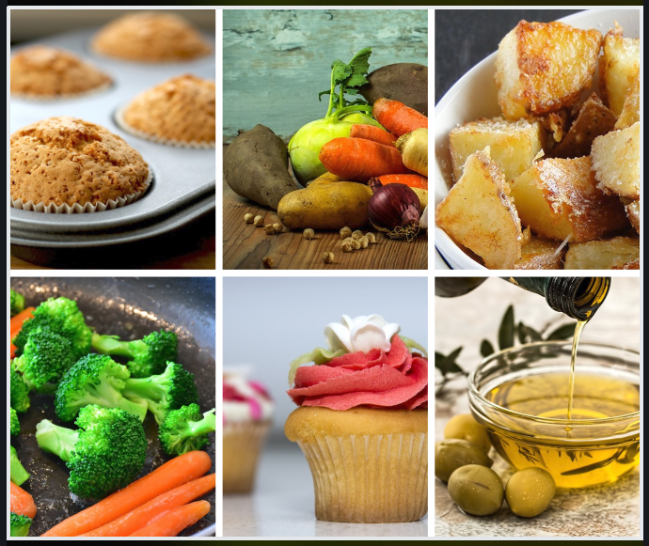

the



of

_________________________________

Recipe Notebook



_________________________________’s



Recipe Notebook



Recipe

Notebook



Notebook Spine:

Note that this spine is shorter than the length of the spine. This is because it’s really difficult (as in almost impossible) to get a full-length spine into the spine pocket. It crunches up when part-way inserted.

There are three sizes to fit whatever size spine you may have. Print the whole page, and then choose the one you want, and cut along the solid lines above and below it. Then fold back just inside light-grey dot­ted lines so that the lines are on the back, not visible. The “flaps” are not quite as wide as the outer part with the title, which is intentional as you don’t want the outer flaps extending beyond the spine la­bel. This will give you three thicknesses, which make your spine piece easier to insert down into the spine. To do this, lay the notebook flat, even pulling the front and back covers even higher than the spine which will give you the greatest amount of space inside the spine. Push the spine piece in straight, slowly and care­fully to keep it from buckling. This gets more difficult the further you push it in. But YOU CAN DO IT!! ☺ Slow ‘n’ easy! If you mess up one, you can use another, adjusting the size. It’s not an exact science anyway.

- - - - - - - - - - - - - - - - - - - - - - - - - - - - - - - - - - - - - - - - - - - - - - - - - - - - - - - - - - - - - - - - - - - - - - - - - - - -

Recipe Notebook / of ________________

- - - - - - - - - - - - - - - - - - - - - - - - - - - - - - - - - - - - - - - - - - - - - - - - - - - - - - - - - - - - - - - - - - - - - - - - - - - -

- - - - - - - - - - - - - - - - - - - - - - - - - - - - - - - - - - - - - - - - - - - - - - - - - - - - - - - - - - - - - - - - - - - - - - - - - - - -

Recipe Notebook / of ___________________

- - - - - - - - - - - - - - - - - - - - - - - - - - - - - - - - - - - - - - - - - - - - - - - - - - - - - - - - - - - - - - - - - - - - - - - - - - - -

- - - - - - - - - - - - - - - - - - - - - - - - - - - - - - - - - - - - - - - - - - - - - - - - - - - - - - - - - - - - - - - - - - - - - - - - - - - -

Recipe Notebook / of ______________________

- - - - - - - - - - - - - - - - - - - - - - - - - - - - - - - - - - - - - - - - - - - - - - - - - - - - - - - - - - - - - - - - - - - - - - - - - - - -